Những thuộc tính css cần quan tâm:

* Flex (<https://flexboxfroggy.com/>)
* Grid (<https://cssgridgarden.com/>)
* Position (w3school)
* Margin (w3school)
* Padding (w3school)
* Border (w3school)
* Font (w3school)
* Background-image(size, repeat,…)

Ex1:

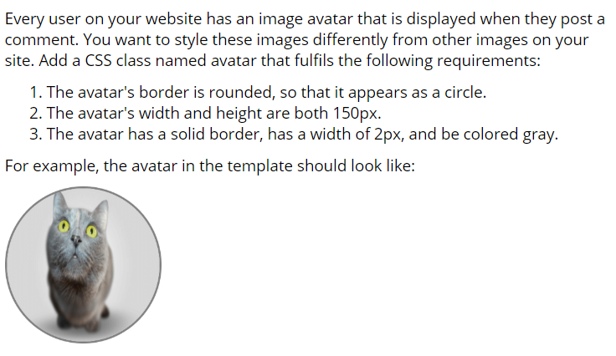

Ex2:

Create a layout of website like picture

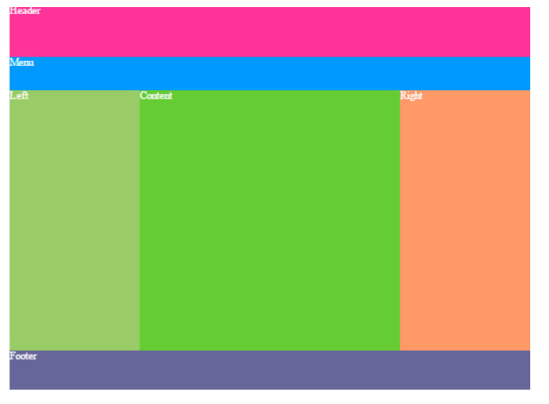

Ex3: Create a layout of website like picture

